**FOR IMMEDIATE RELEASE:**

**COMEDIAN JIM GAFFIGAN ANNOUNCES NEW DATES FOR HIS 2023/2024 *BARELY ALIVE TOUR***

***Tickets Go On Sale Friday, October 6 at 10am local*** *at*[*JimGaffigan.com*](https://jimgaffigan.com/tour-dates)

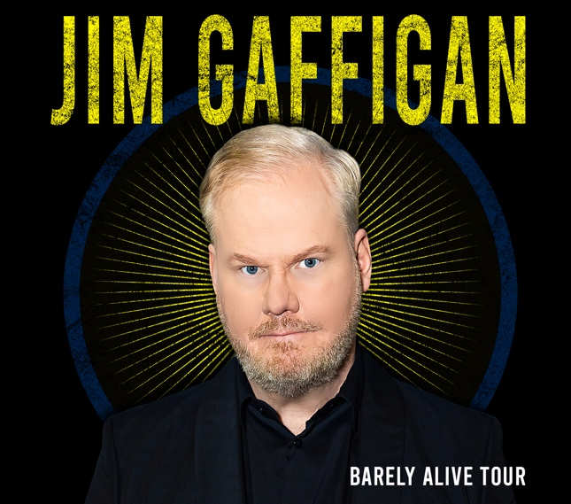

NEW YORK (October 3, 2023) – Comedian **Jim Gaffigan**announced new dates for his 2023/2024 **BARELY ALIVE TOUR**, with additional dates to be announced soon. The new dates may be found below.

Tickets go on sale **Friday, October 6**[at 10am](outlook-data-detector://4)(local time)with**presale**[beginning Wednesday, October 4th at 10am](outlook-data-detector://5) (local time/code: ALIVE) at [JimGaffigan.com](https://jimgaffigan.com/tour-dates).

**JIM GAFFIGAN: BARELY ALIVE TOUR**

Thursday, October 12, 2023 at 7pm **Charlotte, NC** Ovens Auditorium - **4th & final show added**

Wednesday, December 20, 2023 at 7pm **Asheville, NC** Harrah's Cherokee Center - Asheville

Saturday, January 13, 2024 at 8pm **Denver, CO** Paramount Theatre

Saturday, January 20, 2024 at 7pm **Salt Lake City, UT** Delta Center

Saturday, January 27, 2024 at 8pm **Washington, DC** DAR Constitution Hall

Saturday, February 10, 2024 at 8pm **Buffalo, NY** Shea's Buffalo Theatre

Saturday, March 2, 2024 at 8pm **Portland, OR** Keller Auditorium

Wednesday, April 3, 2024 at 8pm **Las Vegas, NV** Wynn Las Vegas - Encore Theater

Friday, April 5, 2024 at 8pm **Las Vegas, NV** Wynn Las Vegas - Encore Theater

Saturday, April 6, 2024 at 8pm **Las Vegas, NV** Wynn Las Vegas - Encore Theater

Saturday, April 13, 2024 at 8pm **Seattle, WA** The Paramount Theatre

Friday, April 19, 2024 at 7:30pm **Boston, MA** The Wilbur

Saturday, April 20, 2024 at 7pm **Boston, MA** The Wilbur

Saturday, April 27, 2024 at 8pm **New York, NY** Beacon Theatre

Gaffigan is a seven-time *Grammy* nominated comedian, actor, writer, producer, two-time *New York Times*best-selling author, three-time *Emmy* winning top touring performer, and multi-platinum-selling recording artist. He is known around the world for his unique brand of humor, which largely revolves around his observations on life.

Gaffigan is a top ten comedian according to Forbes’ most recent comedy list and top ten earning comedian in Pollstar’s 2022 list. He released his 10th comedy special, *Dark Pale*, this year on Amazon Prime Video, an unprecedented achievement for the comedian/actor.  *Dark Pale* was met with critical fanfare with The New York Times calling it, ‘his best yet.”

In 2021 Gaffigan released his 9th special, *Comedy Monster,*on Netflix which was nominated for a Grammy Award.  He was also recently awarded for being the first comedian to reach one billion streams on Pandora.

Gaffigan can currently be seen as the lead in the well-reviewed Sci-Fi dramedy, *Linoleum*, and stars as Mr. Smee in Disney’s *Peter Pan and Wendy*, opposite Jude Law and Yara Shahidi. He will also co-star Jerry Seinfeld, Melissa McCarthy, James Marsden, and Hugh Grant in Netflix’s *Unfrosted*, and co-stars in *Susie Searches*which premiered at TIFF last year and in theaters this summer. Also premiering this summer, Gaffigan joined the cast of HBO Max’s *Full Circle,* a limited series from Steve Soderbergh and Ed Solomon which follows an investigation into a botched kidnapping connecting multiple characters and cultures in present day NY.

On the silver screen, his many credits include *Three Kings*, *Super Troopers 1 & 2*, and *Chappaquiddick*. 2019 was Gaffigan’s biggest year to date with an astonishing eight films releasing, three which premiered at the Sundance Film Festivalincluding *Troop Zero*with Viola Davis and Alison Janney, *Them That Follow*and *Light From Light* – with many festival goers and press calling Gaffigan the “King of Sundance.”   Gaffigan was also recently heard in Disney/Pixar’s highly anticipated animated film, *Luca,*opposite Jacob Tremblay and Maya Rudolph.

Gaffigan also had two films recently in which he debuted as the lead. The comedic film *Being Frank*, and *American Dreamer*, a dark thriller which was the grand finale of 2019 for Jim and features him as a ride share driver who moonlights as a private driver for a drug dealer.

Gaffigan can also currently be seen opposite Ethan Hawke in IFC Films *Tesla,*as well as opposite Josh Hartnett in Saban Films’ *Most Wanted.*

In addition to two seasons of the critically acclaimed semi-autobiographical *The Jim Gaffigan Show*, which he wrote and produced with his wife Jeannie, Gaffigan has guest starred on many television comedies and dramas, ranging from *Portlandia* and*Bob’s Burgers* to the HBO cult hits *Flight of the Concords* to dramatic roles in *Law & Order.*

Gaffigan regularly does humorous commentaries on *CBS Sunday Morning* for which he has won 3 Emmys.  In 2018 Jim served as master of ceremony at *The Al Smith Memorial dinner*.  In 2015, Gaffigan had the great honor of performing for Pope Francis and over 1 million festival attendees at the *Festival of Families*in Philadelphia*.*

Gaffigan and his wife currently live in Manhattan with their five loud and expensive children.

For more info on the tour, go to: [jimgaffigan.com/tour-dates](https://jimgaffigan.com/tour-dates).

# # #

Press Contact: R&CPMK | Rob Greenwald | [rob.greenwald@rcpmk.com](mailto:rob.greenwald@rcpmk.com)