**Commander Naval Installations Command**

**Region North-South-East-West**

**NAVY GALLEY**

**Essential Station Messing (ESM)**

***Navy Base Bedford Falls***

***Swampy Landing Field Galley***

**Concept of Operations**

**and**

**Business Case Analysis**

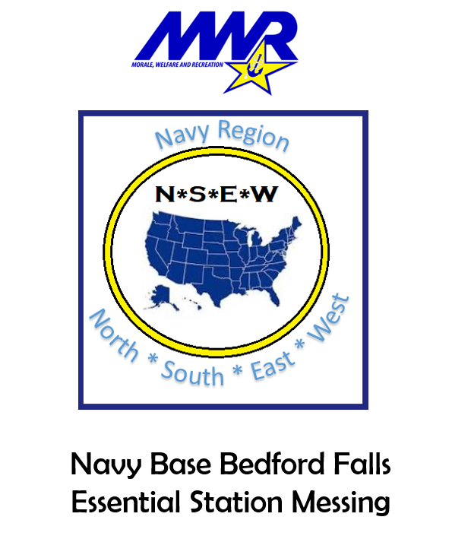

ESM BCA Template 1.0

HQ CNIC OGC/N9L

JMcCT

03NOV 22

**Prepared by:**

**Trublue Civilservant 01 January 2023**

**Galley/Food & Beverage Service**

**Region North-South-East-West**

**(101) 987-6543**

**Trueblue.civilservant.naf@us.navy.mil**

**General Guidance for this BCA Template**

This template is provided to demonstrate the format and presentation of a proper Business Case Analysis (BCA). This is not intended to furnish a substitute for an authentic business plan, but rather offered as an example of the approach necessary to adequately resolve the business problem and present the business solution. Any submission to HQ CNIC that merely copies and parrots the language found in this template (or merely substitutes a few words and rephrases the template contents) will be summarily rejected upon programmatic review.

In like manner, the portions of this template that are left open for specific input are crucial to the value and effectiveness of the BCA. Do not merely add vague generalities or paste powerpoint slides that fail to engage in authentic analysis.

The purpose of the BCA is to submit a business idea; assemble the relevant facts and figures; identify costs and revenues; analyze these facts against the benefits and risks of moving to a new business solution; and then compare these to the benefits and risks of not changing the current business model or otherwise not taking action. Based upon this analysis, describe the preferred end-state business model and propose the step-by-step plan to implement the new solution.

In the simplest extreme, the art and science of drafting a BCA can be summed up in conceptualizing how much information and how much analysis would it take to convince you to confidently invest your life savings in a business proposal. Better yet, for those who are married, how much would to take to convince your spouse? Do you have children? Would you bet their college savings accounts on this BCA? Meet this standard, and chances are that the document will be well-received at HQ CNIC.

**Table of Contents**

*As a minimum, a Business Case Analysis (BCA) should include:*

1.0. Executive Summary

2.0. Current Concept of Operations and Proposed Options

2.1. Business Objective

2.2. Business Proposition/Statement of Issues.

2.3. 'As-Is' Current Galley Program Configuration

2.4. Snapshot of Operations

2.5. Risks, Challenges, Obstacles

2.6. Potential Courses of Action (COAs) and Discussion

2.7. Comparison of COAs—‘Rack-n-Stack’

3.0. Navy Galley Program Way Forward

3.1. ‘To Be’ New Navy Galley Business Model

3.2. Management Strategy

3.3. Project Governance

Don’t know what a BCA is all about? That’s odd…during your job interview three years ago, it sure sounded like you did. Well, anyway, try checking out some easy BCA primers on:

<https://www.youtube.com/watch?v=yD253PIzsIE>

<https://business.adobe.com/blog/basics/business-case>

3.4. Financials

3.5. Procurement Strategy

4.0. Required Decision-Making and Action

**Legal Authorities**

**CNICINST 4061.4** indicates that the CNO has delegated to CNIC “authority to organize, man, train, maintain and equip assigned Navy base operating support functions and infrastructure,” to include Navy galleys.

**CNICINST 4061.1A** establishes the rules relating to patronage of Navy galleys.

**CNICINST 4061.6** provides authority and guidance in regard to audits of Navy galleys ashore.

**DoD Manual 1338.10** encompasses the DoD Food Service Program (DFSP).

**DoD 7000.14-R Financial Management Regulation (FMR), Volume 12, Chapter 19** serves as the financial template for DoD Food Service Programs.

**10 U.S.C. § 2492** states that Department of Defense MWR nonappropriated fund instrumentalities are authorized “to provide or obtain food services beneficial to the efficient management and operation of the dining facilities on military installations offering food services to members of the armed forces.”

**SECNAVINST 7043.5C** specifically promulgates and adopts the authority of 10 U.S.C. § 2492 in its application to Navy galleys.

**OPNAVINST 4535.1C** appoints CNIC FFR as the Navy’s Randolph-Sheppard Act (RSA) Program manager, and the responsibility for day-to-day management has been assigned to N9L. As per this Instruction, as well as the RSA statute and Department of Education Regulations, a military dining facility such as a Navy Galley is considered a ‘cafeteria’ subject to blind vendor priority. Other food venues not characterized as a cafeteria may operate under an RSA permit.

**List of Attachments**

Do not underestimate the importance of providing relevant, accurate, and detailed information to back up the discussion and analysis of the BCA.

Attachment A: Historical Galley Spend Plan FY 2022

Attachment B: Estimated ESM Revenues/Costs

Attachment C: Proposed ESM Menu(s)/Themes/Cuisine Options

Attachment D: Proposed ESM Footprint/Floorplan/Drawings & Illustrations

**1.0. EXECUTIVE SUMMARY**

Currently, the Navy Galley Program core business model is based upon ‘cafeteria’ type service and subject to the general management at the regional level and contracting support furnished by NAVSUP Fleet Logistics Centers (FLCs) spread across the country. This model has successfully served the Navy, and it sailors, for at least a century. However, the current business model of Navy Galleys is now facing stiff headwinds and significant challenges:

* Minimum wage increases (currently $15/Hour) of contracted galley workers without commensurate increases in Navy Galley budgeted resources.
* Ever-changing and evolving dining habits of sailors.

As a consequence of the above, Navy Region North-South-East-West proposes a transition from a traditionally contracted ‘cafeteria’ galley to an Essential Station Mess (ESMs) based upon a model of dining supported and serviced by open patronage MWR Food & Beverage concessions. Although there are benefits associated with ESMs, there are also some risk factors, all of which are addressed and resolved and mitigated in this Business Case Analysis.

An ESM—sometimes referred to as a Rations-in-Kind (RIK) Feeder—is a MWR NAF managed food and beverage operation that feeds RIK Sailors at no charge from selected menu options. The overall operational design is based on food courts/campus-style dining. The benefits of an ESM are:

* Variety of venues/locations.
* Wide assortment of menu options/food styles.
* Current availability of MWR food & beverage operations.
* Opportunity to open new locations.
* Flexibility to rebrand or change food options based upon customer demand.
* Inclusiveness regarding food vendors, including MWR, NEX, Randolph-Sheppard Program blind vendors, or commercial franchise operations.
* Reduced costs due to alternative revenue streams and wider patron base.
* Sailors may choose to enhance meal choices by paying the difference for higher priced menu items, yet still benefit from subsidized meals.
* May operate with or without military assigned personnel.
* Significant cost savings.

Accordingly, the new ESM business model is proposed in order to provide a flexible, modular, 21st century dining solution to the Navy’s need to efficiently and economically provide sustenance to sailors while still ensuring that proper standards of quality and nutrition are upheld.

**2.0 CURRENT CONCEPT OF OPERATIONS** **AND PROPOSED OPTIONS**

**2.1. Business Objective**

The objective is to run the Navy galley program more efficiently, increase and improve the flexibility of the business solution at each installation galley, operate on a cost-effective basis, provide a more attractive array of dining choices to the sailor, while at all times ensuring the highest quality of food and service to all patrons.

**2.2. Business Proposition/Statement of Issues.** The primary goals of this CONOPS/BCA:

* Ensure that the Navy continues to offer sailors nutritional dining options in conformity to BUPERS guidelines and in support of CNO Homeport Ashore Feeding Policy.
* Offer meals and dining venues that are compatible with evolving societal standards for the 21st Century sailor.
* Reduce the expenses to the galley program while avoiding unnecessary pass-on costs to sailors.
* Maintain Culinary Specialist (CS) employment and readiness.

**2.3. 'As-Is' Current Galley Program Configuration**

The basic structure of the ashore galley business model currently in place is little different than what has existed for nearly a century: traditional cafeteria style managed by a Food Service Officer (FSO), operated by Culinary Specialists (CS) with contracted support, as needed depending upon the location and mission.

*Describe in detail the current galley operation*

**2.4. Snapshot of Navy/CNIC Enterprise Galley Operations**

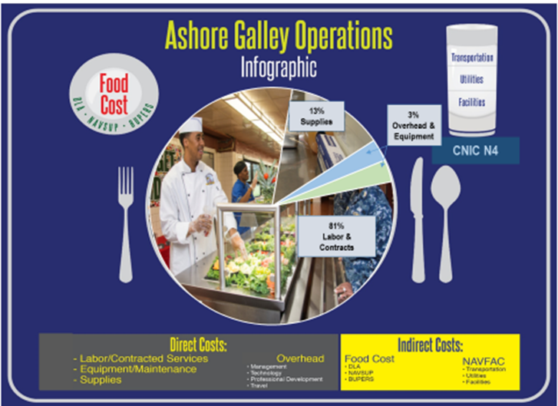

*Basic description of the business operational stance of the current galley operation*

|  |  |  |  |  |  |  |  |
| --- | --- | --- | --- | --- | --- | --- | --- |
| Galley  Location | Navy Staff | | Contract  Support | Equipment Supplies  Utilities | Food | Meals Served | Cost/Meal |
| Swampy Landing Field Galley | Number | Cost | Cost | Cost | Cost |  | Cost |
| CS  GS  NAF |  |  |  |  |  |  |
|  |  |  |
|  |  |  |
|  |  |  |
|  |  |  |  |  |  |  |
|  |  |  |  |  |  |  |

**2.5. Risks, Challenges, Obstacles.** The following challenges face the continued operation and success of the Navy Base Bedford Falls Swampy Landing Field Galley:

*Financial Challenges*

* The increase of minimum wages has seriously compressed the operating margins.
* Funding from Congress/DoN has not kept pace with inflation.

*Customer Base Challenges*

* Sailors of the 21st Century prefer the flexibility of ‘campus style’ dining.
* The customer base is currently limited to active duty sailors, thus foreclosing a more robust and financially sustaining business model in which all potential patrons (civilian employees, retirees, veterans, government contractors) are allowed to dine.

*Contracting Challenges.* Although NAVSUP Contracting Officers have sought to provide quality contracting support to CNIC and Regional galley programs, there are shortcomings and limitations inherent in the current business model. These challenges exist not only in regard to Navy Base Bedford Falls, and Navy Region North-South-East-West, but to the CNIC galley enterprise as a whole, which ultimately impacts the cohesiveness of operations at all levels:

* Challenges and difficulties exist in communications between HQ CNIC MWR Galley Program (N925), regional galley operations, and the far-flung FLC contracting offices.
* A diversity of contracting strategies, approaches, styles, and procedures exists in regard to both contract formation and contract administration among the various contracting officers in the FLCs.
* Unnecessary variations of galley Statement of Work/Performance Work Statements have been implemented at different locations across the CNIC enterprise.
* Long-lead times are routinely mandated for contracting support.
* Delays in processing and awarding new or follow-on contracts have necessitated extensions and bridge contracts that result in financially disadvantageous results.
* Difficulty of moving funds between each cost objective.
* In CONUS, inconsistency of application of policy, particularly in regards to the requirements to provide blind vendor priority to the operation galleys (classified as 'cafeterias') under the Randolph-Sheppard Act as mandated by 20 U.S.C. §107, et. seq., and 34 C.F.R. § 395.

*Attempted Remedial Measures.*

*List and discuss all actions taken to remediate or overcome problems identified above*.

**2.6. Potential Courses of Action (COAs) and Discussion**

*COA # 1 ___________________________*

*Concept:*

* *Pros:*

Provide enough facts, detail, and description to afford the reader/reviewer a clear understanding of both the upside and downside of each course of action.

* *Cons:*
* *Mitigation of Cons:*

*COA # 2 ___________________________*

*Concept:*

* *Pros:*
* *Cons:*
* *Mitigation of Cons:*

*COA # 3 ___________________________*

*Concept:*

* *Pros:*
* *Cons:*
* *Mitigation of Cons:*

**2.7. Comparison of COAs—‘Rack-n-Stack’**

*Justification statement identifying one COA as superior to all other alternatives.*

*Discuss benefits, particularly in regards to:*

* *Estimated savings per location per year*
* *Improvement of menu options*
* *Anticipated positive response from sailors and the means of assessing/surveying satisfaction*
* *Benefits to MWR revenue*
* *Flexibility and opportunities to innovate within the chosen business model*

**3.0. NAVY GALLEY PROGRAM WAY FORWARD**

**3.1. ‘To Be’ New Navy Galley Business Model**

*Provide:*

* *Full description of design and operation of the new model;*
* *Funding*
* *Staffing*
* *Capital investments needed*

**3.2. Management Strategy**

The management strategy of the new galley business endstate may prove to be the largest savings of revenue of the entire model. By creating a consistent operational template and delegating management to the individual ESM operations, the ‘middleman’ costs currently embedded in the Navy’s galley structure can be eliminated. Currently, such costs are significant, as can be seen by the following data:

*Provide most recent information.*

**3.3. Project Governance**

*Discuss necessity/benefit regarding issuance of:*

* *Instructions*
* *SOPs*
* *Operation Manuals*
* *Progress Reporting*
* *Measures of Success*
* *Site Visits/Inspections*
* *Audits*

*Include any proposed governance materials as an additional BCA Attachment.*

**3.4. Financials**

*Refer to attachments and provide commentary and analysis as needed.*

*Describe financial support requirements, and if relevant, sources thereof.*

In addition, the proposed ESM business construct may be capable of employing the Uniform Financial Management (UFM) process applicable to MWR food & beverage support to APF galley program. Funds appropriated to DoD and available for MWR programs are authorized by 10 U.S.C. § 2491 to be converted to nonappropriated funds via the UFM practice and thereafter treated as NAFs and expended in accordance with laws applicable to NAF. Guidance and authority is further provided in DoDI 1015.10 and DoDI 1015.15.

**3.5. Procurement Strategy**

Thanks to the inherent structure of the ESM model, significant contracting will be eliminated by virtue that MWR-type operations will provide galley functions rather than engaging through the federal acquisition process to obtain private sector contract support. To the extent that contractual matters will still need to be addressed, either the Region or the ESM will be able to utilize the Non-Appropriated Fund (NAF) procurement process offered by CNIC N9. Current galleys contractual support from the individual NAVSUP contracting agent will no longer be necessary. This will result in:

* Ability to rely upon more responsive in-house contracting.
* Benefits of operating under NAF procurement rules established by CNIC.
* Elimination of long lead times.
* Elimination of complex and time-consuming creations of galley Performance Work Statements.
* Reduction of risk of litigation, such as bid protests to the Government Accountability Office.

The underlying ESM business agreement between the Region and MWR Food & Beverage will be accomplished under a basic MOA as authorized under 10 U.S.C. § 2492. Execution of such MOAs is routine practice throughout the CNIC enterprise, and can be quickly and efficiently executed. In fact, Congress specifically authorized the use of this process in regards to galley operations:

§2492. *Nonappropriated Fund Instrumentalities: Contracts With Other Agencies and Instrumentalities to Provide and Obtain Goods and Services*

An agency or instrumentality of the Department of Defense that supports the operation of the exchange system, or the operation of a morale, welfare, and recreation system, of the Department of Defense may enter into a contract or other agreement with another element of the Department of Defense or with another Federal department, agency, or instrumentality-

(1) to provide or obtain goods and services beneficial to the efficient management and operation of the exchange system or that morale, welfare, and recreation system; or

***(2) to provide or obtain food services beneficial to the efficient management and operation of the dining facilities on military installations offering food services to members of the armed forces.***

*Provide additional detail relating to the procurement strategy of the specific ESM venue(s) being proposed in this BCA.*

**4.0. REQUIRED DECISION-MAKING AND ACTION**

*Indicate the timetable and incremental steps necessary to segue to the new business model.*

**POAM**

|  |  |  |
| --- | --- | --- |
| Date | Action | Comments |
|  |  |  |
|  |  |  |
|  |  |  |
|  |  |  |
|  |  |  |
|  |  |  |
|  |  |  |
|  |  |  |
|  |  |  |
|  |  |  |
|  |  |  |
|  |  |  |
|  |  |  |
|  |  |  |
|  |  |  |
|  |  |  |
|  |  |  |
|  |  |  |

Submitted by:

Trublue Civilservant 01 January 2023

Galley/Food & Beverage Service

Region North-South-East-West

(101) 987-6543

[Trueblue.civilservant.naf@us.navy.mil](mailto:Trueblue.civilservant.naf@us.navy.mil)

*Review:*

*Region MWR/N9*

*Region Office of Counsel*

*REGCOM*