INGENICO MOVE/5000

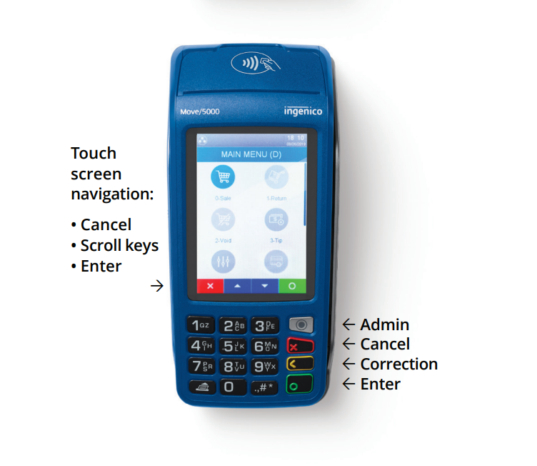

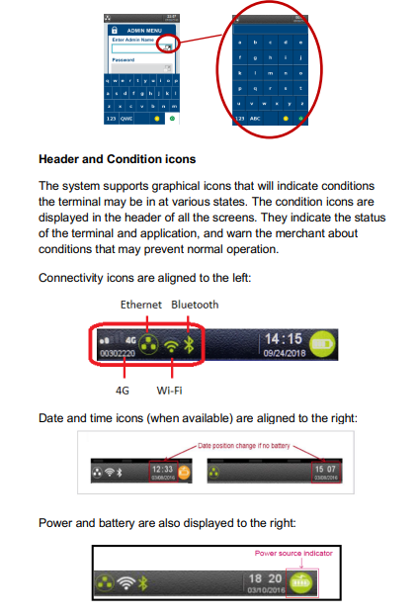

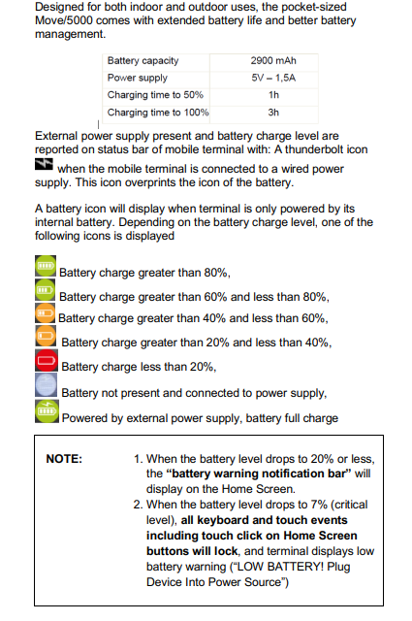
NOTE: ALWAYS KEEP TERMINAL CHARGED!
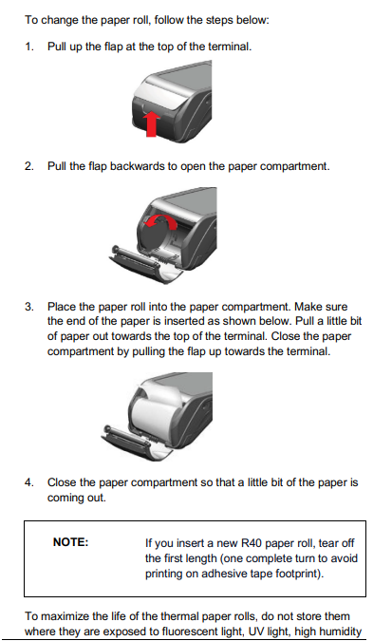
TO TURN TERMINAL ON: PRESS GREEN ENTER KEY
TO TURN TERMINAL OFF: PRESS # AND YELLOW KEY TOGETHER (NOTE: Terminal will not turn off when being charged.
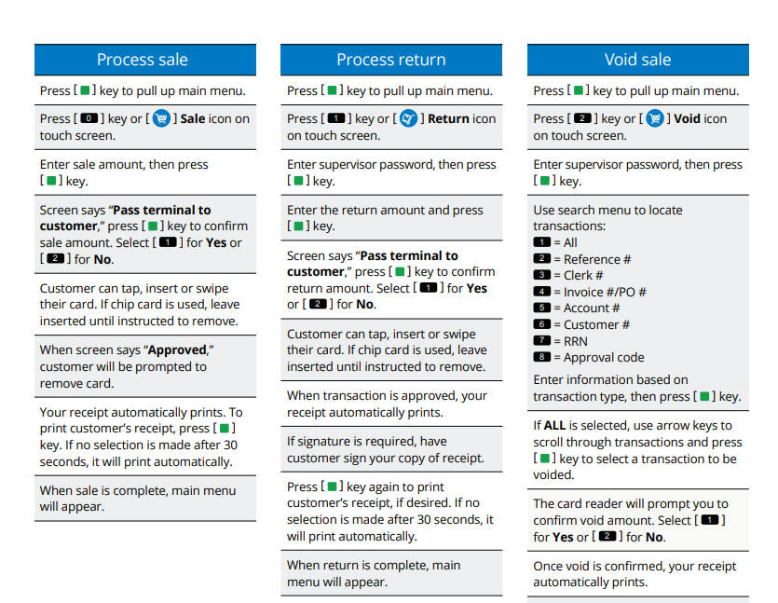

FOR MERCHANTS WITH TIP OPTION:
Follow above instructions for SALE
After entering amount of sale, there will be a TIP SCREEN with the below options
- Tip Amount
- No Tip

Note: Terminal may prompt for a customer signature. Customer may sign on screen or hit RED Cancel button and terminal will complete transaction without signature.

If customer is using a VISA/Mastercard backed Debit card, terminal will prompt for a PIN. Please DO NOT ENTER PIN, hit GREEN ENTER button to bypass and continue transaction.

Generate Reports:
Hit Green Enter Key
Select OTHER Icon
Reports
1 – Detail (Provides Each transactions processed)
2 – Summary (Provides totals for all card types processed)
If you want to confirm amount in batch, reports must be run prior to settlement.

TERMINALS MUST BE MANUALLY SETTLED FOR PAYMENTS TO BE PROCESSED!
Hit Green Enter
Select Settlement Icon
At the end of every successful batch settlement, a Summary Settlement Report will automatically print. “SETTLEMENT SUCCESSFUL” will print on the report.

