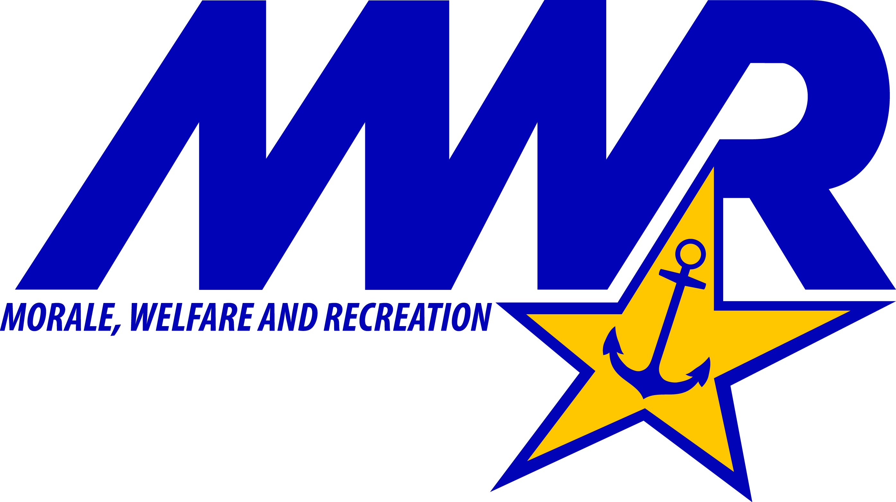

**FLEET AND FAMILY READINESS MARKETING**

**STRATEGIC PLAN**

**FOR THE**

**ADOPTION OF THE NEW NAVY MWR LOGO**

*Last Updated January 2018*

**Table of Contents**

Background

Goals

Objectives

MWR Logo

Related N92 Logos

Timeline

**Appendices**

A. N94P Points of Contact

B. Navy MWR Logo Guide

**Background**

At the 2016 Fleet Readiness (N92) Regional Advisory Board (RAB) meeting, the Fleet and Family Readiness marketing director (N94P) proposed refreshing and standardizing the Navy Morale, Welfare and Readiness (MWR) logo. N92 representatives from all Navy regions discussed the benefits of standardization, as well as the negative implications of using different versions of the current logo in different ways. They ultimately voted to adopt a slightly revised version of the Navy MWR logo that would be used enterprise-wide. They also requested a multi-year strategic plan for adopting the new logo.

After the RAB, N92 leadership also decided to revise several other sub-program logos, to further strengthen the Navy MWR brand. Details about the new Navy MWR logo, as well as related logos, are included in the Navy MWR logo guide (Appendix B).

**Goals**

The goal of this plan is to provide region and installation marketing professionals with a phased approach for the adoption of the new Navy MWR logo and other related N92 logos. The intent is to avoid spending a great deal of money rebranding Navy MWR facilities and materials with new logos. Instead, a large percentage of materials or signs featuring old logos will be phased out through attrition. Ultimately, the adoption of the new Navy MWR logo will result in a more standardized approach to marketing this flagship program, and, ultimately, increase awareness of Navy MWR services.

**Objectives**

Gradually phase out old versions of the Navy MWR logo and aggressively build the brand using the new logo.

Begin using the new related N92 logos to further promote Navy MWR brand awareness.

Share resources with field marketing professionals to assist with this transition.

**MWR Logo**

The new Navy MWR logo includes four variations:

1. Stylized MWR text with a star/anchor
2. Stylized MWR text with a star/anchor and the words “Morale, Welfare and Recreation” below MWR
3. Stylized MWR text with a star/anchor and an installation name below MWR
4. Stylized MWR text with a star/ anchor, the words “Morale, Welfare and Recreation” and an installation name below MWR

Approved colors and font information are included in the Navy MWR logo guide (Appendix B). The logo guide and logo files can be found on the MWR marketing resources page: http://www.navymwr.org/resources/marketing.

***The logo guide also includes directions for adding base locations to the new Navy MWR logo.***

**Related Logos**

The following N92 logos will remain in circulation as is; please refer to the appropriate program logo guide for specific usage instructions:

* Child and Youth Programs
* Fisher House
* Navy Child Development Home
* Navy Gateway Inns & Suites

The following N92 logos have been redesigned to incorporate the new Navy MWR logo:

* MWR Aquatics
* MWR Bowling
* MWR Community Recreation
* MWR Deployed Forces Support
* MWR Fitness
* MWR Food and Beverage
* MWR Marinas
* MWR Navy Getaways
* MWR Auto Skills
* MWR Golf
* MWR Liberty
* MWR Libraries
* MWR Movies
* MWR Sports (to be used for intramural sports)

The following N92 logos are intended primarily for CNIC headquarters use (they can be used locally only in coordination with headquarters):

* All Navy Sports
* Dine on the Go
* Mission Nutrition
* MWR Accreditation Program
* MWR Navy Entertainment
* Navy Ashore Galleys
* Navy First
* Navy General Library Program (seal)
* Navy Voting Assistance Program
* NOFFS
* Operation Megaphone

If you have questions about a logo that does not appear on the list above, please contact FFR marketing headquarters staff (Appendix A).

Logo guides and logo files can be found on the MWR marketing resources page: http://www.navymwr.org/resources/marketing.

***When designing materials that highlight multiple MWR sub-programs (e.g. Community Recreation and Movies), it is best to use the general MWR logo, which encompasses all sub-programs. All collateral pieces should include only ONE MWR logo.***

**Timeline**

***Immediate Action***

* All newly created/ordered marketing products, uniforms/clothing and signage will use the new logos provided FFR marketing headquarters staff.
* Any marketing professionals who require assistance with adding an installation name to the Navy MWR logo will contact FFR marketing headquarters staff.

***Year 1***

All of the following materials will be updated to include the new Navy MWR logo (and other new N92 logos, as necessary) in Fiscal Year 2017:

* Banners
* Brochures
* Bulletins
* Business/information cards
* Electronic publications
* Fact sheets
* Fliers
* Folders
* Guidebooks
* Handbooks
* Letterhead and envelopes
* Mobile applications
* Newsletters
* Pamphlets
* Posters
* PowerPoint briefs
* Press Releases
* Social media sites
* Table tents
* Theater slides
* Websites

NOTE: Please remove materials featuring old logos from circulation, unless doing so would result in significant financial burden for the installation or region.

***Year 2***

All of the following materials will be updated to include the new Navy MWR logo (and other new N92 logos, as necessary) in Fiscal Year 2018:

* Bags (fitness, tote, etc.)
* Civilian uniforms
* Interior signage
* Name tags
* Promotional materials: pens, mugs, key chains, magnets, etc.
* Wearable materials: hats, shirts, etc.

NOTE: Please remove materials featuring old logos from circulation, unless doing so would result in significant financial burden for the installation or region.

***Year 3***

All of the following materials will be updated to include the new Navy MWR logo (and other new N92 logos, as necessary) in Fiscal Year 2019:

* Exterior signage
* Floor mats
* Key cards/ID cards
* Video

NOTE: Please remove materials featuring old logos from circulation, unless doing so would result in significant financial burden for the installation or region.

**Assessment**

Logo usage will be evaluated during program standards visits from select FFR program representatives, which will take place in each region. Headquarters marketing staff can assist with logo adoption efforts, providing resources and information as necessary.

**APPENDIX A: N94P Points of Contact**

|  |  |  |  |
| --- | --- | --- | --- |
| **Name** | **Title** | **Phone** | **Email** |
| Steve Buckley | Marketing Specialist | 901-874-6593 | Steve.buckley@navy.mil |
| Janay Powell | Marketing Branch Head | 202-433-9155 | janay.powell@navy.mil |
| Ingrid Mueller | Marketing Specialist | 901-874-6628 | ingrid.mueller@navy.mil |